Dimitar and Josh (Captains)
Work with the Competition Director and Operations Team members to resolve any questions regarding the rules of the competition or scoring methods before the competition begins. Use the Ticketing System.
Rules: https://cp.tc/overview
Scoring: https://scoring.cp.tc

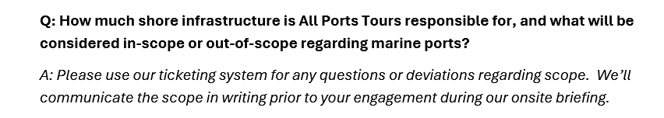

Review Below and Take Note to the Verbiage

Engineering Bonus Tip!
Notice Information about Director of IT Bailey Finn …….
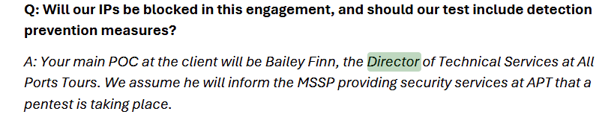
Prior Year Director had access to the network … get creative. ………….
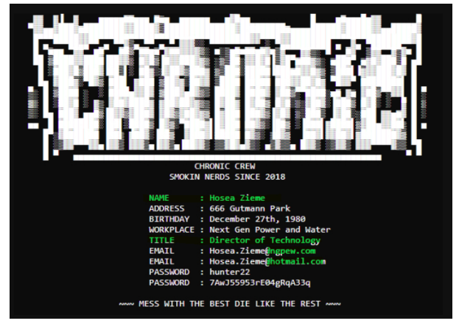

EVERYONE
- THERE IS A POTENTIAL EASTER EGG FOR BONUS POINTS
- DO NOT ASK OR ANSWER PERSONAL QUESTIONS FROM THE STAFF IF PROMPTED!
- Response:
“Unfortunately I have to focus on the security assessment at this time. However, I can meet with you after to answer any questions.”

